**Sprint 2 Report**

*Group Contributions*

Jacqui O’Sullivan: I worked on the Staff class and implemented functions for adding and removing movies, as well as modifying individual Movie information. These were implemented in a way to be most easily linked to front-end controllers and consistently display the correct list of Movies available in the Cinema as provided by staff members. I wrote tests for those functions, and made sure that the Staff module linked well with Movie and Cinema to keep the application working cohesively with no errors. We also discussed ways to easily extend the program for the next sprint, for example extending from the Staff class to create Manager and reuse those functions.

*Project Board*

*Next Steps*

*Git commit history*

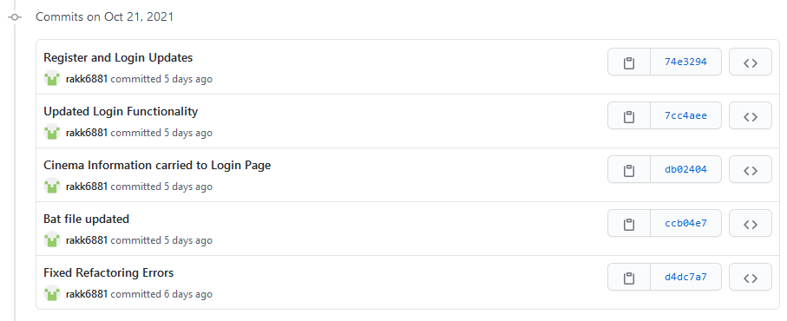The following section will convey the work done throughout the duration of sprint 2. Approximately there was 40 commits to the repository while working on the project during this sprint.

In sprint 1 majority of the items in the sprint backlog were not finished as mentioned in the sprint 1 report. However, for these unfinished items the only logic left to implement for most of them was the front-end code for the GUI. Hence, initially our commits were done to complete these tasks. Once this was done the group moved onto working on the new items in the sprint 2 backlog.

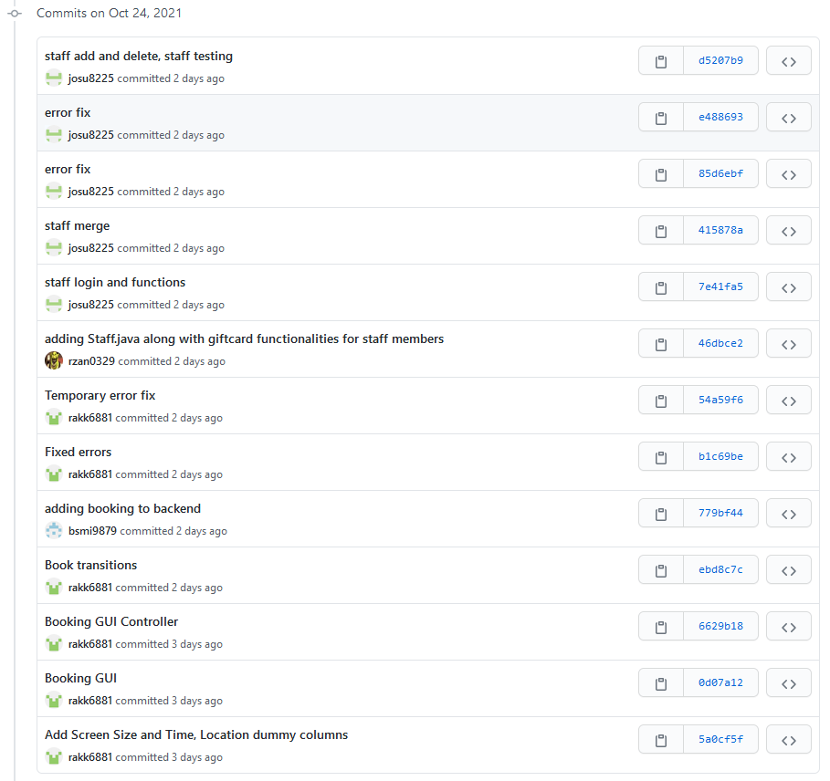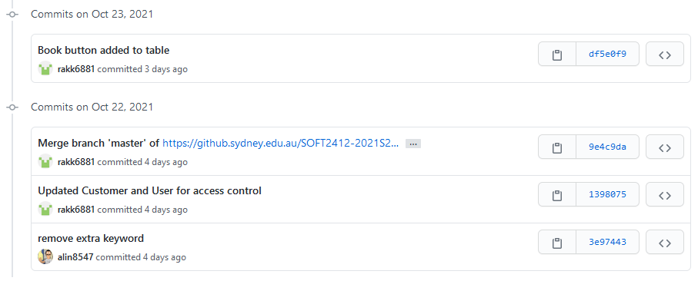Furthermore, of the new tasks the logic for adding the book button was added as well as the functionality of it only working when the customer is logged in as a user and not a guest. For this task the screens on the GUI and the backend logic for booking the movie still needed to be implemented.

Following on, the information for screen size and time for each movie were added onto the GUI so that customers or guests can view the information about movies in a readable table. Then the further logic for booking that was still needed which was mentioned above was implemented in the commits so that customers can now select how many tickets they wish to book for their desired movie. This included error checks ensuring that the booking functionality was fully operation. Finally, on the 24th of October a Staff class was created which extended from our Customer class. Thus, this class will be used for the later functionality regarding staff members of the cinema.

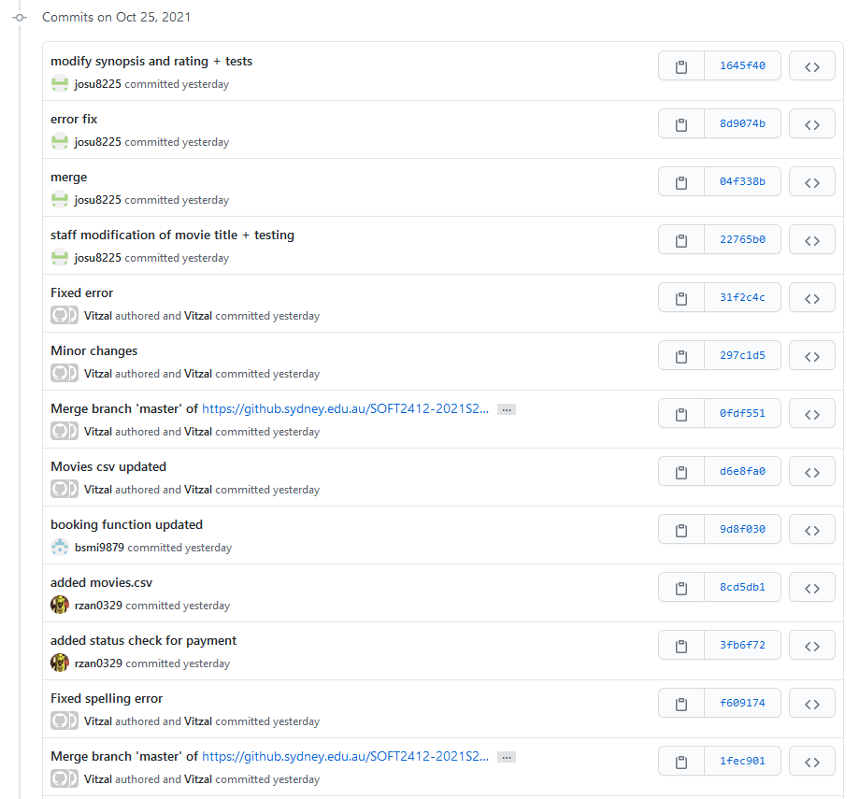

The work completed on the 25th of October regarding our payment functionality was initially done. This included the logic regarding whether a customer pays with their credit card or a gift card. The code written for these commits ensured that a file of valid credit cards and gift cards was read into our program and that if a valid credit/gift card was entered the payment was processed and a transaction ID was returned.

Additionally, a CSV file was added which our program reads in to gathered extra information about movies. This was then used to add the requirement of customers and guests being able to see more information in our movie list table. Hence, users were now able to click a link on each movie in the table which would direct them onto a page which displays information regarding a movie’s title, cast and synopsis.

Lastly, final edits were made to the Staff class which would be able to be built upon in the final sprint 3. As well, testing was added for the functions which were added to the back end of our program. These changes made up the final commits made during sprint 2. Overall, a lot of code was added which contributed to a majority of the tasks in sprint 2 being completed or almost completed. Hence, the functionality of this project is almost complete going into the final sprint 3 meaning that the group is certainly on track to finish the project requirements.